client-server architecture

1. What is client-server architecture?

Ans - Client-server architecture is a computing model in which the server hosts, delivers, and manages most of the resources and services requested by the client. It is also known as the networking computing model or client-server network as all requests and services are delivered over a network.

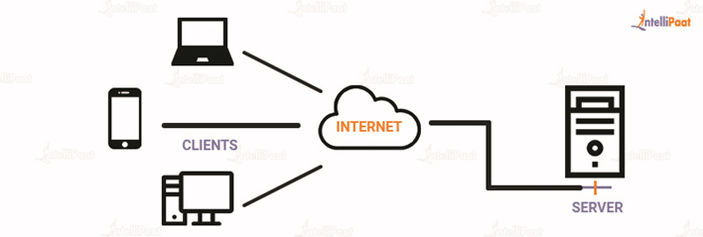

2. What kind of protocol is being used in a client-server architecture?

Basically, there are three types of protocols used in client severe architecture:-

1 FTP(file transfer protocol)- use to transfer files between computers

2 HTTP(hypertext transfer protocol) - The Hypertext Transfer Protocol is an application protocol for distributed, collaborative, hypermedia information systems that allow users to communicate data on the World Wide Web.

3 SMTP(simple mail transfer protocol) - SMTP is a set of communication guidelines that allow the software to transmit an electronic mail over the internet

3. What is the application using client-server architecture?

Ans - the application that is using client-server architecture are:-

1. Printing data is sent from computer to printer.
2. Sending and receiving mail
3. Flipkart user sends the request to the particular thing and with its request data is sent back to the user
4. Netflix, prime, etc

4. Network protocol and its application?

Ans - Network protocols are a set of rules, conventions, and data structures that dictate how devices exchange data across networks. The network layer is used to transfer data from the transport layer data link layer and vice versa

5. What is Memory swapping?

Memory swapping is a memory reclamation method wherein memory contents not currently in use are swapped to a disk to make the memory available for other applications or processes.

6. How do two processors switch each other?

**Unable to find the answer**

8. types of Network topology?

Ans -the different types of network topology are:

1. Mesh topology: in a mesh topology, every device is connected to another device vie a particular channel
2. 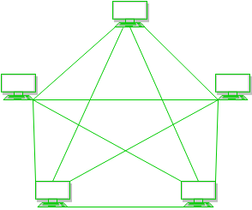
3. Star topology: In star topology, all the devices are connected to a single hub through a cable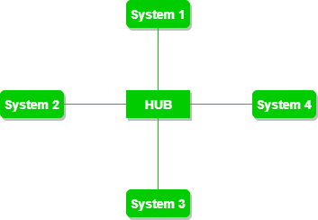
4. Bus topology: Bus topology is a network type in which every computer and network device is connected to a single cable

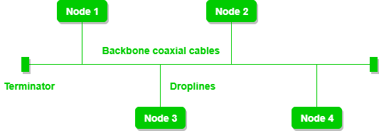

5:ring topology:In this topology, it forms a ring connecting devices with its exactly two neighboring devices.

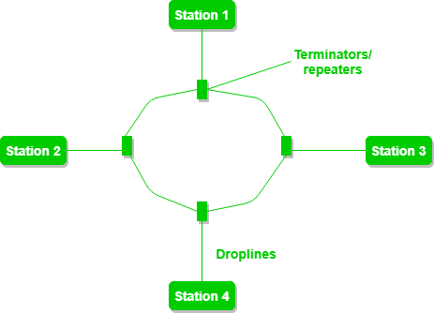

6 : tree topology: This topology is the variation of Star topology. This topology has a hierarchical flow of data.

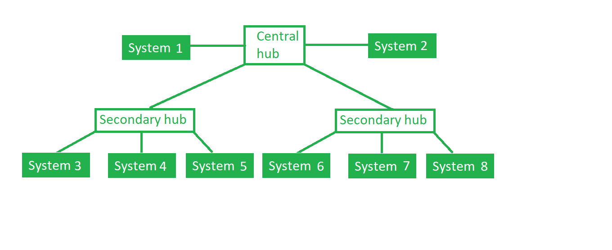

7.What is java and python?

Ans Java is a high-level, class-based, object-oriented programming language that is designed to have as few implementation dependencies as possible.

Python is an interpreted, object-oriented, high-level programming language with dynamic semantics.

8.Difference between java and python?

|  |  |  |
| --- | --- | --- |
| Parameter | Python | Java |
| Code | Python has less lines of code. | Java has longer lines of code. |
| Framework | Compare to JAVA, Python has lower number of Frameworks. Popular ones are DJango, Flask. | Java has large number of Frameworks. Popular ones are Spring, Hibernate, etc. |
| Syntax | Syntax is easy to remember almost similar to human language. | Syntax is complex as it throws error if you miss semicolon or curly braces. |
| Key Features | Less line no of code, Rapid deployment and dynamic typing. | Self memory management, Robust, Platform independent |
| Speed | Python is slower since it uses interpreter and also determines the data type at run time. | Java is faster in speed as compared to python. |
| Databases | Python’s database access layers are weaker than Java’s JDBC. This is why it rarely used in enterprises. | (JDBC)Java Database Connectivity is most popular and widely used to connect with database. |
| Machine Learning Libraries | Tensorflow, Pytorch. | Weka, Mallet, Deeplearning4j, MOA |
| Practical Agility | Python has always had a presence in the agile space and has grown in popularity for many reasons, including the rise of the DevOps movement. | Java enjoys more consistent refactoring support than Python thanks on one hand to its static type system which makes automated refactored more predictable and reliable, and on the other to the prevalence of IDEs in Java development . |

Write a program you have a list of whether the IP is valid or not?

9. Python:-

x=input("enter the ip address ")

tot=x.split(".")

k=0

if(len(tot) is 4):

for i in tot:

if(int(i)>=0 and int(i)<=255):

k=k+1

if(k==4):

print("ip address is valid")

else:

print("ip address is invalid")

10.Java

import java.util.Arrays;

import java.util.*;

class Main

{

public static boolean isValidInet4Address(String ip)

{

String[] groups = ip.split("\\.");

if (groups.length != 4) {

return false;

}

for(int i=0;i<4;i++)

{

if(Integer.parseInt(groups[i])<0 && Integer.parseInt(groups[i])>255)

{

return false;

}

}

return true;

}

public static void main(String[] args)

{

Scanner sc =new Scanner([System.in](http://system.in/));

System.out.println("enter the ip-adress");

final String ipAddress=sc.nextLine();

// Validate an IPv4 address

if (isValidInet4Address(ipAddress)) {

System.out.print("The IP address " + ipAddress + " is valid");

}

else {

System.out.print("The IP address " + ipAddress + " isn't valid");

}

}

}

|  |  |  |
| --- | --- | --- |
| **task** | **Expected time** | **Actual time** |
| 1 | 20min | 20 min |
| 2 | 30min | 30min |
| 3 | 30 min | 30 min |
| 4 | 20 min | 10 min |
| 5 | 20 min | 10 min |
| 6 | 20 min | 40 min |
| 7 | 20 min | 20 min |
| 8 | 20 min | 30 min |
| 9 | 30 min | 1 hour |
| 10 | 30 min | 1.5 hour |